Assignment 06
PS490 Research Studies

Directions: Be sure to save an electronic copy of your answer before submitting it to Ashworth College for grading. Unless otherwise stated, answer in complete sentences, and be sure to use correct English, spelling, and grammar. Sources must be cited in APA format. Your response should be double‐spaced; refer to the “Format Requirementsʺ page for specific format requirements.

- Apply the APA Style Guide and Format to your First Draft and Bibliography.

- Submit the formatted version of your draft.

Grading Rubric

Please refer to the rubric on the next page for the grading criteria for this assignment.

 | Reading Assignments  Text Readings  There is no textbook in this course  Additional Readings  DIRECTIONS: To access ProQuest articles, you MUST first open a Web browser window to the ProQuest Library; otherwise, you will be denied access to the articles when you click the links. Once your browser is open to ProQuest, simply click on the link for the article you need to read. For detailed instructions on how to access ProQuest, click here. For non-ProQuest articles, use the provided Internet link to access the Required Readings material.  ProQuest Articles  - There are no ProQuest readings assigned in this lesson.  Internet Links  - APA Formatting and Style Guide
 | Lecture Notes  Writing, even for professionals, is always a challenge. It takes time, patience, and effort. Allowing yourself enough time for writing in your timeline is a must. The quality of your writing will reflect the time and preparation you put into it.  Start with a first draft but remember that your first draft is not going to be your final paper. You should plan on writing multiple drafts and revisions. You will find that when writing your first drafts, you may still have holes that you need to fill with additional research.  Do not let coherence be your objective in writing the first draft. Coherence is very important but it will not come until after several revisions. Even when you have all the information you need, your writing will not be perfectly clear the first time around.  If you have your organizational structure in place, just fill in the parts with what needs to be there in content. Don’t worry about perfection at this time. Forget about grammar, spelling or even complete sentences at this point. Focus on just getting your thoughts down and in their proper places in the paper.  Style of Prose  Even as you create your first draft, be mindful of your style of prose. Consistency is key, in order to have your report flow smoothly. Make a habit of following the APA guidelines right from the start, as this will help you learn the discipline. For example, the APA prefers that in writing your report you:  - Use the active voice rather than the passive voice. For example:  Active: Jones surveyed the participants.  Passive: The participants were surveyed by Jones.  - Use the past tense for literature review but present tense for presenting conclusions.  - Use first person reference when appropriate instead of third person. For example:  First person: I analyzed the data.  Third person: The researcher analyzed the data.  - Refer to people in the study in a more personal manner, as in participants, individuals, students or respondents versus the generic term subjects.  (Source: Leedy, P. D. & Ormond, J. E. (2005). Practical Research: Planning and Design. (8th ed.) New Jersey: Pearson Prentice Hall.  Heading levels  There are five levels of headings in APA Style.  Levels indicate the hierarchy of importance and scope of each heading and subheading. The extent of using the different levels depends on the length and complexity of the paper. Usually, short papers or articles use two to three levels, but longer papers necessitate up to five levels. Level 1 encompasses a broader topic and levels 2 to 5 covers narrow to more detailed topics.  Level 1 Section heading  Level 2 Subsection heading  Level 3 Subsection of a subsection heading  Level 4 Subsection under a subsection of a subsection heading  Level 5 Subsection under the three subsections heading  Guideline  - No heading is needed for the first part of a paper as it is already assumed as the introduction  - Headings and subheadings are not accompanied by letters or numbers  - Use as many levels as required in your paper to present the most organized structure  - The same level of heading or subheading should be of equal importance regardless of the number of subsections under it  - Use at least two subheadings for each section and subsection, or use none  - Start with level 1 through 5  - Paragraph begins below levels 1 and 2, whereas for levels 3-5, the paragraph begins in line with the headings  - Capitalize each word for levels 1 and 2  - For levels 3-5, the headings are indented and end with a period  - Only the first word is capitalized for levels 3-5  To give you a clearer picture, here is the recommended format and example for the heading levels.  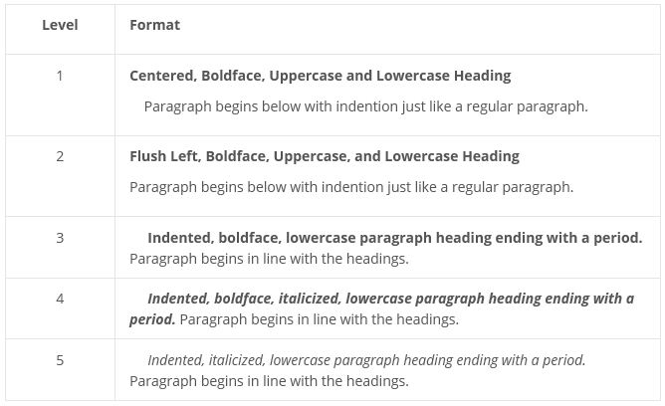  (Retrieved on April 27, 2014 from: http://apaformat.org/apa-headings-and-subheadings/)  Margins  According to apastyle.org, it is best to set “uniform margins of at least 1 in. (2.54 cm) on the top, bottom, left, and right of every page. Use your word-processing software to add a header that will appear at the top of every page that includes the running head and the page number. The header appears within the top margin, not below it.”  Additional guidance is offered about how information should be presented:  Lists  Lists, such as numbered lists and bulleted lists, may be used in APA Style.  Each item on the list is punctuated at the end by a comma, semicolon, or period, depending on the grammatical structure of the list. Numbers are followed by periods and are not in parentheses.  In running text, a series of items is designated by letters in parentheses: (a) first item, (b) second item, and (c) third item.  Tables  Tables can help you present a large amount of material efficiently. Table layout needs to be logical and easy for readers to understand. Here are some guidelines on formatting your table.  - Place each table on a separate page at the end of your manuscript, after the reference list.  - If font size and style are not specified by the organization for which you are writing (e.g., publisher, university), the suggested font is 12-point Times New Roman.  - Margins depend on the size of the table but must be at least 1 in. (2.54 cm).  - Tables may use single-spacing or one-and-a-half spacing (p. 229).  - Information necessary for understanding the table and definitions of abbreviations used within the table appear in a table note.  Figures  Many types of figures can help you present data to the reader, including graphs, charts, maps, drawings, and photographs. A good figure is easy to read with elements large enough to be read easily. Here are some guidelines on creating your figure.  - Place each figure on a separate page at the end of your manuscript, after any tables (or after the reference list, if there are no tables).  - Place a caption below each figure describing its contents and defining any abbreviations used in the figure.  Read more, including how to format the running head and title page, at http://www.apastyle.org/learn/quick-guide-on-formatting.aspx.  Also refer to the following sources for additional formatting guidance:  APA Basics tutorial: http://www.apastyle.org/learn/tutorials/basics-tutorial.aspx  Quick guide to references: http://www.apastyle.org/learn/quick-guide-on-references.aspx  APA Style Blog: http://blog.apastyle.org/apastyle/2013/01/asking-the-right-question-how-can-the-reader-find-the-source.html

